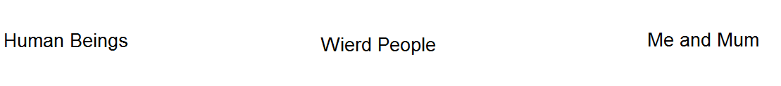
ME AND MUM

Me and mum are twisted

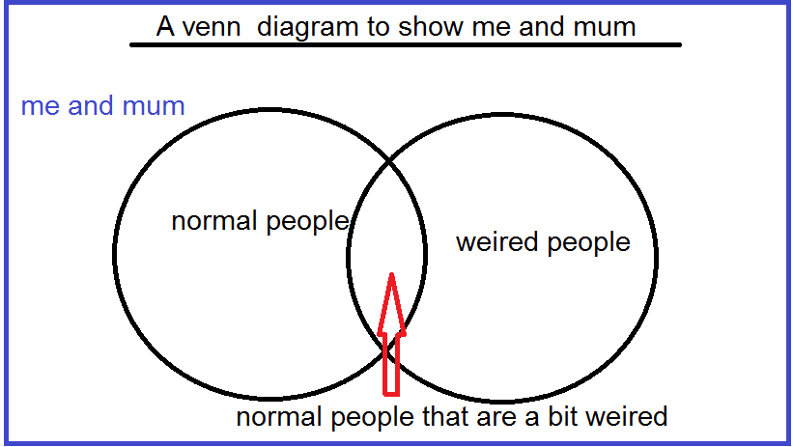

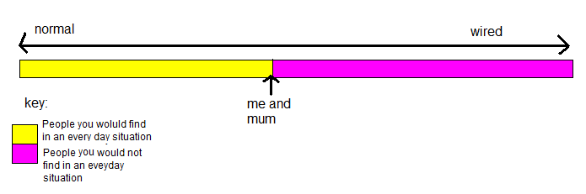

Me and Mum are the weirdest people you would find in an everyday situation. There are people that are weirder than Me and Mum, but you would not find them in an everyday situation.

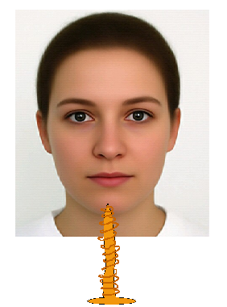

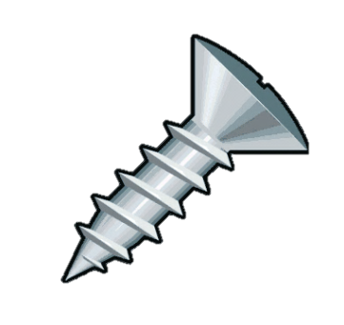

Me and Mum are screwed up in the Head.

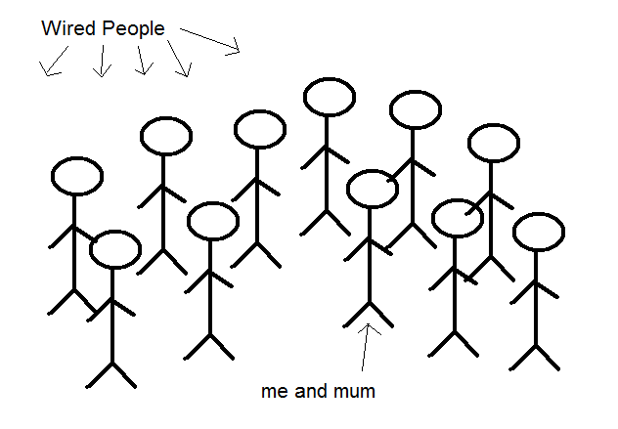

There are some wired people in this world and watch out; me and mum are one of them.
